**Experiment 9:** write an Arduino program to control LED ON, OFF time by using Potentiometer with Arduino Uno.

**INTERFACING POTENTIOMETER**

AIM: To write an Arduino program to control LED ON, OFF time by using Potentiometer with Arduino Uno.

**APPARATUS REQUIRED:**

1. PC

2. Arduino IDE

3. LED-1No

4. Bread Board-1No

5. Resistor-560Ω-1No

6. Potentiometer-1No

7. Wires

**CIRCUIT DIAGRAM:**

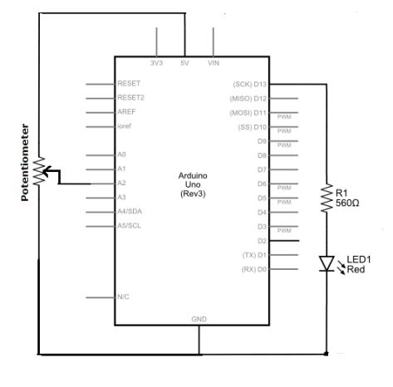

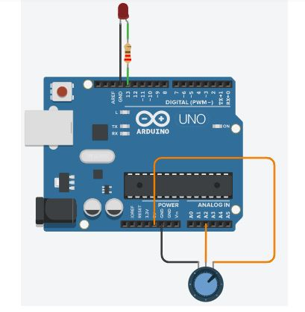

**PROCEDURE:**

**1. Connect the circuit as per the circuit diagram.**

**2. Connect Arduino to your PC.**

**3. Open the Arduino IDE in computer and write the program.**

**4. Compile the program for any errors and upload it to the Arduino.**

**5. Observe the output LED ON when pressing Push Button.**

**PROGRAM:**

**int potentiometerPIN = 2;**

**// It select the input pin connected to the middle terminal of the potentiometer**

**int LEDpin = 13; // It selects the LED pin**

**int value = 0; // value initialized to store the coming value from the sensor**

**void setup()**

**{**

**pinMode(LEDpin, OUTPUT); // The LED pin is declared as the output pin**

**}**

**void loop()**

**{**

**value = analogRead(potentiometerPIN);**

**// It reads the value from the sensor**

**digitalWrite(LEDpin, HIGH); // turn the LEDpin ON**

**delay(value); // delay time in milliseconds**

**digitalWrite(LEDpin, LOW); // turn the LEDpin OFF**

**delay(value); // the delay time depends on the value stored from the sensor**

**}RESULT: Thus the LED ON, OFF time is varied by Potentiometer using Arduino**

**Uno**